Direct Object

✅ What Is a Direct Object?
# Source: AI Source: Provided by: [Data Path: Persons Table -> ID Column: 1, Name_En Column: Motasem Essam] -> From: [Chatgpt (GPT-4-turbo)] on [8/4/2025]
A Direct Object is a noun, pronoun, or noun phrase that receives the action of a transitive verb directly.
It answers the question "what?" or "whom?" after the verb.

🔸 Key Features:
# Source: AI Source: Provided by: [Data Path: Persons Table -> ID Column: 1, Name_En Column: Motasem Essam] -> From: [Chatgpt (GPT-4-turbo)] on [8/4/2025]
- Follows an action verb (not a linking verb).
- Receives the effect of the action.
- Answers:
  - What? (the verb does what?)
  - Whom? (the verb affects whom?)

🔸 Examples of Direct Objects:
# Source: AI Source: Provided by: [Data Path: Persons Table -> ID Column: 1, Name_En Column: Motasem Essam] -> From: [Chatgpt (GPT-4-turbo)] on [8/4/2025]
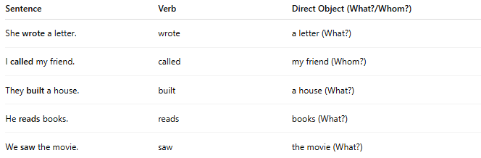
Sentence | Verb | Direct Object (What?/Whom?)
She wrote a letter. | wrote | a letter (What?)
I called my friend. | called | my friend (Whom?)
They built a house. | built | a house (What?)
He reads books. | reads | books (What?)
We saw the movie. | saw | the movie (What?)

🔸 Not a Direct Object:
# Source: AI Source: Provided by: [Data Path: Persons Table -> ID Column: 1, Name_En Column: Motasem Essam] -> From: [Chatgpt (GPT-4-turbo)] on [8/4/2025]
If a verb is intransitive (does not take an object), then there is no direct object:
- She slept. ❌ (no object)
- He arrived late. ❌ (no object, only adverb)

🔸 Quick Test:
# Source: AI Source: Provided by: [Data Path: Persons Table -> ID Column: 1, Name_En Column: Motasem Essam] -> From: [Chatgpt (GPT-4-turbo)] on [8/4/2025]
Ask “Verb + what?” or “Verb + whom?”
- "They bought what?" → a car ✅ (Direct Object)

